**Process Design Document (PDD)**

**______________________________**

**LinkedIn Standard Approach**

**Table of Contents**

**I. Introduction**

I.1 Purpose of the Document

I.2 Objectives

I.3 Key Contacts

I.4 Minimum Prerequisites for Automation

**II. As-Is Process Description**

II.1 Process Overview

II.2 Applications Used in the Process

II.3 As-Is Process Map

II.4 Detailed As-Is Process Steps

II.5 Input Data Description

**III. To-Be Process Description**

III.1 To-Be Detailed Process Map

III.2 Parallel Initiatives / Overlap (if applicable)

III.3 In Scope for RPA

III.4 Out of Scope for RPA

III.5 Business Exceptions Handling

III.6 Application Error and Exception Handling

III.7 Reporting

**IV. C# Custom App**

# **Introduction**

## I.1 Purpose of the Document

The Process Definition Document outlines the business process consisting of recruitment of prospects on the LinkedIn Sales Navigator platform by the Sales Department, which has been chosen for automation using Robotic Process Automation (RPA) technology.

The document describes the sequence of steps performed as part of the business process, the conditions and rules of the process prior to automation and how they are envisioned to work after automating it. This specifications document serves as a base for developers, providing them the details required for applying robotic automation to the before mentioned business process.

## I.2 Objectives

The process that has been selected for RPA is the recruitment of prospects by the Sales Department. This consists of searching for prospects via specific filters on LinkedIn Sales Navigator and approaching them via a connection request and a suggestive message. If this connection request is further accepted by the prospect, the process will be continued by sending them another message which will give more details.

The business objectives and benefits expected by the Business Process Owner after automation of the selected business process are:

* *To have this process automated as much as possible*
* *To reduce time consumed with searching prospects and collecting data*
* *To reduce time consumed by connecting the prospects and sending messages*
* *To reduce time verifying the accepted connection requests and sending further messages*
* *To reduce human errors*
* *Better Monitoring of the overall activity by sending final e-mail reports which detail the number of prospects that have been approached and the number of prospects that have accepted the connection request*

## I.3 Key Contacts

The specifications document includes concise and complete requirements of the business process and it is built based on the inputs provided by the process **Subject Matter Expert (SME)/ Process Owner.**

The **Process Owner** is expected **to review it and provide signoff for accuracy** and completion of the steps, context, impact and complete set of process exceptions. The names have to be included in the table below.

|  |  |  |  |
| --- | --- | --- | --- |
| Role | Name | Contact details  (email, phone number) | Notes |
| Process SME | Nicoleta Maria Cirnat | *@fortech.ro | Point of contact for questions related to process details & exceptions |
| Process SME | Claudia Kiss | *@fortech.ro | Point of contact for questions related to process details & exceptions |
| Process SME | Diana Racila | *@fortech.ro | Point of contact for questions related to process details & exceptions |
| Process SME | Ionut-Lucian Vulc | *@fortech.ro | Point of contact for questions related to process details & exceptions |
| Process Reviewer | Mircea Rusu | *@fortech.ro | Point of contact for questions related to process details & exceptions |
| Process Owner/ Approver for production | Adina Ghetiu | *@fortech.ro | Escalations, Delays etc. |

## I.4 Minimum Prerequisites for Automation

The minimum prerequisites for automation are:

1. *Filled in Process Design Document*
2. *Test Data to support development*
3. *User access and user accounts creations (licenses, permissions, restrictions to create accounts for robots)*
4. *Credentials (user ID and password) required to logon to machines and LinkedIn account*
5. *Dependencies with other projects on the same environment*

# **As-Is Process Description**

## II.1 Process Overview

General information about the process selected for RPA prior to automation.

|  |  |  |
| --- | --- | --- |
| # | Item | Description |
| 1 | **Process full name** | LinkedIn Standard Approach |
| 2 | **Process Area** | Sales |
| 3 | **Department** | Sales |
| 4 | **Process short description**  (operation, activity, outcome) | The Sales Department searches every day on LinkedIn for prospects via filters. They take each prospect that is of interest and copy all the needed details to an excel document. Afterwards, they contact each prospect via a connection request and send an initial message. For the prospects who have accepted the connection request there will be a following message (more detailed) that the Sales Department sends. |
| 5 | **Role(s) required for performing the process** | Sales representatives |
| 6 | **Process schedule and frequency** | Daily, Monday to Friday, 9 am – 6 pm |
| 7 | **# of prospects or filters processed /reference period** | ~ 50 prospects/day |
| 8 | **Average handling time per prospect** | 15 min |
| 9 | **Peak period (s)** | Beginning of sales campaign |
| 10 | **Transaction Volume During Peak period** | 1000 prospects |
| 11 | **Total # of FTEs supporting this activity** | 1.0 FTE |
| 12 | **Expected increase of volume in the next reference period** | No |
| 13 | **Level of exception rate** | No expected exceptions |
| 14 | **Input data** | Details about the campaign, what jobs opened, and years of experience required for the position etc. |
| 15 | **Output data** | An Excel document filled with the personal details related to each prospect resulted for that campaign, in a particular template and messages sent. |

## II.2. Applications Used in the Process

The table includes a comprehensive list all the applications that are used as part of the process automated, at various steps in the flow.

|  |  |  |  |  |  |
| --- | --- | --- | --- | --- | --- |
| # | Application name & version | System  Language | Thin/Thick Client | Environment/  Access method | Comments |
| 1 | LinkedIn Sales Navigator | EN | Thick  Client | Web Browser | Searching prospects in order to connect with them, to send them messages and to collect their personal details shared through this social media. |
| 2 | Excel | EN | Thick Client | Microsoft Office Application | Storing prospects data |

## II.3 As-Is Process Map

**High Level As-Is Process Map:**

This chapter depicts the As Is business process at a High Level to enable developers to have a high-level understanding of the current process.

II.3.1. High Level As-Is Process Map for Robot 1.2



II.3.2. High Level As-Is Process Map for Robot 2



II.3.3. High Level As-Is Process Map for Robot 3

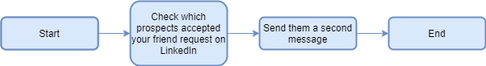

**Detailed As-Is Process Map:**

This chapter depicts the As Is business process at a Detailed Level to enable developers to have a detailed understanding of the current process.

II.3.4. As-Is Process Map for Robot 1.2

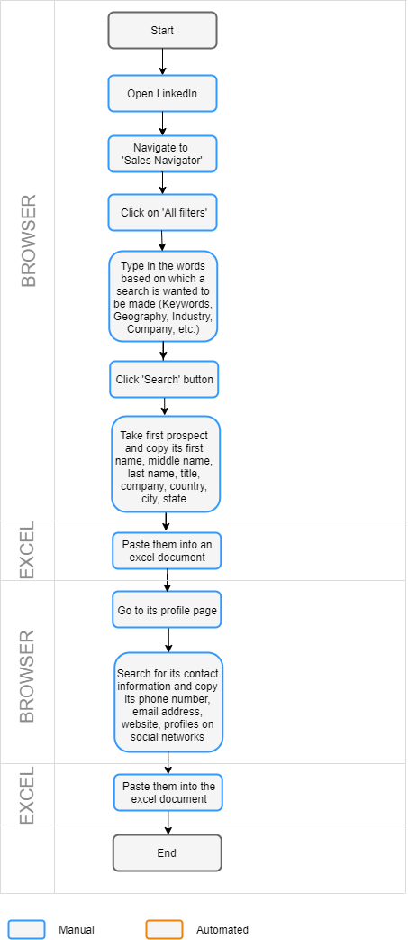

II.3.5. As-Is Process Map for Robot 2

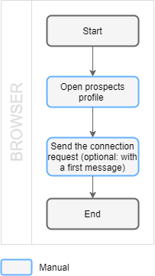

II.3.6. As-Is Process Map for Robot 3

## 

## II.4 Detailed As-Is Process Steps

This chapter depicts the As-Is business process in detail to enable the Developer to build the automated process.

Detailed As-Is Process Steps for Robot 1.2:

|  |  |  |  |  |  |  |
| --- | --- | --- | --- | --- | --- | --- |
|  | Detailed As-Is Process Steps | | | | | |
| Step | Input | Description | Details (Screen/ Document/ Video recording Index) | Exception Handling | Possible Actions | Business Rules Library Index |
| 1. | The URL for this social website LinkedIn | Open LinkedIn. |  | Browser freezes. Also, it might close suddenly. | Close it and open it again and verify that we are on the right page. |  |
| 2. | LinkedIn credentials | The user logs into LinkedIn and accesses the Sales Navigator page. |  | At this point, exceptions may be caused by the login page not loading properly or by not finding the fields needed to enter/type in the credentials. The credentials will be retrieved from Orchestrator so we will not encounter problems caused by incorrect user or password. | Verify if the user’s already logged in.  Reload the login page. |  |
| 3. |  | The user clicks on ‘All filters’ to open the window ‘Filter your search’ in which he has to type in the keywords for the filter. |  | Browser freezes, click activity can’t be performed and thus the window will not appear. | Check if the window was opened, if not, reload the page and click again on ‘All filters’ |  |
| 4. | List of keywords for the search/ filter | The user types in the words based on which a search is wanted to be made (Keywords, Geography, Industry, Company, etc.) in the window “Filter your search” into the corresponding field. |  | If for one field there is no word to be entered, then there could not be selected the option. | Check for not given inputs and skip these fields when typing in this window. |  |
| 5. |  | Clicks on ‘Search' button. |  |  |  |  |
| 6. |  | The user takes a prospect and copies its first name, middle name, last name, title, company, country, city, state. |  | One of these personal data may not be provided. If there will not always be the same personal information shared within this social media with us then this will affect the order in which these are presented and thus it will increase the difficulty level for the robot.  Also, the robot may not be able to retrieve these details in the form that usually the user gets. | Opt for the most reliable methods of extracting these personal data.  Picking these data as best as we can, in the closest form possible. |  |
| 7. |  | Paste the following: first name, middle name, last name, title, company, country, city, state into an excel document. |  | The very high volume of data that was predicted to be extracted (there are hundreds of prospects per campaign/filter) may change the place where these are stored. |  |  |
| 8. |  | The user then goes to the personal page of the prospect. |  | The page may not open. |  |  |
| 9. |  | Searches for its contact information and copies its phone number, email address, website, profiles on social networks. |  | One of these personal data may not be provided. If there will not always be the same personal information shared within this social media with us then this will affect the order in which these are presented and thus it will increase the difficulty level for the robot.  Also, the robot may not be able to retrieve these details in the form that usually the user gets. | Opt for the most reliable methods of extracting these personal data.  Picking these data as best as we can, in the closest form possible. |  |
| 10. |  | Paste the following: phone number, email address, website, profiles on social networks into the excel document. |  | The very high volume of data that was predicted to be extracted (there are hundreds of prospects per campaign/filter) may change the place where these are stored. |  |  |

Detailed As-Is Process Steps for Robot 2:

|  |  |  |  |  |  |  |
| --- | --- | --- | --- | --- | --- | --- |
|  | Detailed As-Is Process Steps | | | | | |
| Step | Input | Description | Details (Screen/ Document/ Video recording Index) | Exception Handling | Possible Actions | Business Rules Library Index |
| 1. | The URL for the profile of the prospect | Open LinkedIn profile of the prospect. |  | Frozen browser. Page might close suddenly. | Refresh page, or close and open again and verify that we are on the right page. |  |
| 2. | The message for the prospect | Clicking on the ‘connect’ button and typing in the message that will accompany the connection request |  | Certain elements of the page may not load correctly or entirely (e.g. drop-down menus). | Refresh page, or close and open again and verify that we are on the right page. |  |

Detailed As-Is Process Steps for Robot 3:

|  |  |  |  |  |  |  |
| --- | --- | --- | --- | --- | --- | --- |
|  | Detailed As-Is Process Steps | | | | | |
| Step | Input | Description | Details (Screen/ Document/ Video recording Index) | Exception Handling | Possible Actions | Business Rules Library Index |
| 1. | The URL for this social website LinkedIn | Open LinkedIn. |  | Browser freezes. Also, it might close suddenly. | Refresh page, or close and open again and verify that we are on the right page. |  |
| 2. |  | Clicking the message inbox icon. If the connection request was sent with a message or if the prospect only responded to the message and not to the connection request, here is where new connections or messages will be highlighted. |  | Browser freezes. Also, it might close suddenly. Message inbox not loading properly. | Refresh page, or close and open again and verify that we are on the right page. |  |
| 3. |  | Clicking the notifications icon. If the connection request was sent without a message here is where the new connections will appear. |  | Browser freezes. Also, it might close suddenly. Notification box not loading properly. | Refresh page, or close and open again and verify that we are on the right page. |  |
| 4. | The second message for the prospect | Sending the second message to the prospects who had responded to us. The response can be: acceptation of the connection request or response to the message accompanying the connection request (a positive or a negative response). |  | Browser freezes. Also, it might close suddenly. Message boxes not loading properly. | Refresh page, or close and open again and verify that we are on the right page. |  |

## II.5 Input Data Description

For each campaign a sales representative sets the keywords based on which to be made a search on Sales Navigator and further, a list of prospects to be processed is returned.

|  |  |  |  |  |  |  |
| --- | --- | --- | --- | --- | --- | --- |
| Step | Sample  (Print-screen) | Input type | Location | Inputs are standard? (Yes/ NO) | Inputs are structured? | Data to be used from |
|  | n/a |  |  |  |  |  |

# **To-Be Process Description**

This chapter highlights the expected design of the business process after automation.

## III.1 To-Be Detailed Process Map

In this subchapter is presented the To-Be Detailed Process Map for each of the three robots. Those maps describe which steps from the As-Is Diagrams, presented previously, were able to be automated, which had to remain manual, and what extra steps needed to be added in order for the robot to work accordingly (e.g., Verify if the robot is logged in into the LinkedIn account).

III.1.1. To-Be Process Map for Robot 1.2

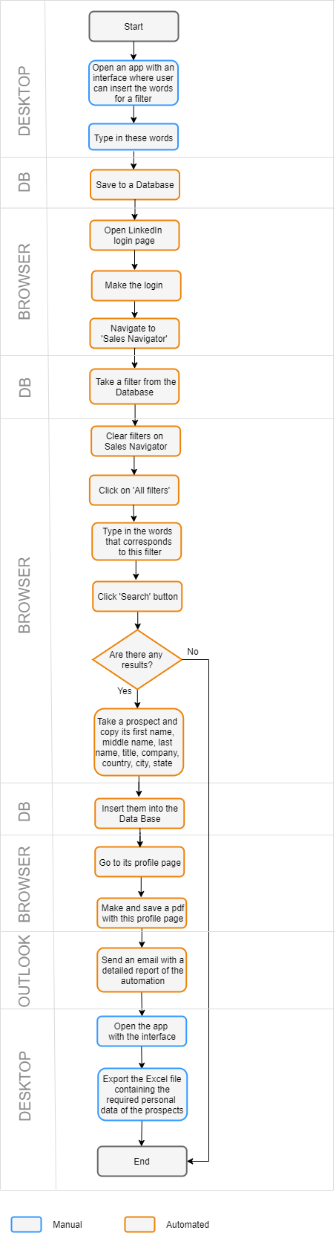

III.1.2. To-Be Detailed Process Map of Robot 2

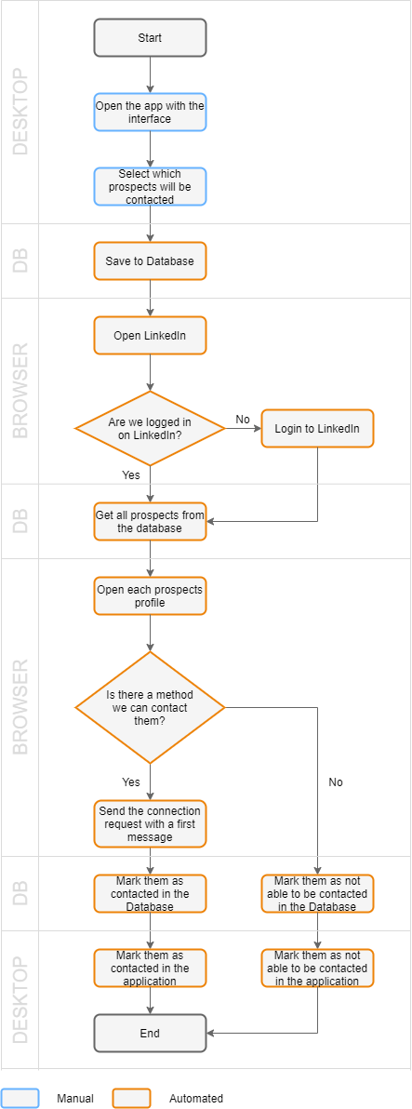

III.1.3. To-Be Detailed Process Map of Robot 3

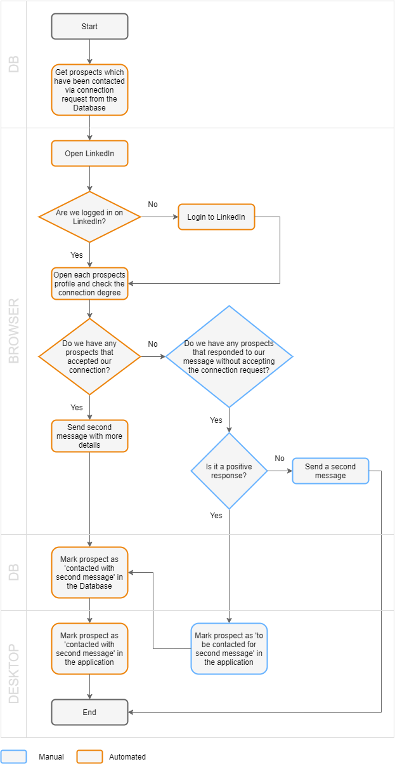

## III.2 Parallel Initiatives/ Overlap (if applicable)

This chapter captures the proposed Business, Process & System changes in near future and its impact

|  |  |  |  |  |  |
| --- | --- | --- | --- | --- | --- |
| S. No | Initiative Name | Process Step(s) where it is identified | Impact on current automation request? How? | Expected Completion Date | Contact person for more details |
|  | n/a |  |  |  |  |

## III.3 In Scope for RPA

The activities **in scope for RPA**, are listed here:

III.3.1. Activities in scope for robot 1.2

1. *Login to LinkedIn*
2. *Navigate to Sales Navigator*
3. *Search filters on LinkedIn Sales Navigator*
4. *Get the number of resulted prospects from the search*
5. *Get for all the prospects found their details and save them in a database*
6. *Download a pdf file of the profile of each prospect*
7. *Send an email with a detailed report of the automation*

III.3.2. Activities in scope for robot 2

1. *Get the filters that were already processed from the database*
2. *For each processed filter get the prospects which we want to be contacted*
3. *For each of those prospects send a connection request together with a first message*
4. *Send an email with a detailed report of the automation*

III.3.3.In scope activities for robot 3

1. *Get from DB the lists of filters that were already processed*
2. *For each list, get from DB the prospects that received the friend request and the second message*
3. *For those prospects that accepted the friend request, send the second message and mark the success of the process with a status 3 in the DB*
4. *Send an email with a detailed report of the automation*

## III.4 Out of Scope for RPA

III.4.3Out of scope activities for robot 3

1. *Check if a prospect did not accept the friend request but responded to our message*

The activities **OUT of scope of RPA**, are listed here:

|  |  |  |  |  |
| --- | --- | --- | --- | --- |
| Sub-process  (if case) | Activity (step) | Reasons for Out of Scope* | Impact on the To-Be | Possible measures to be taken into consideration for future automation |
|  | Prospects that only responded to message. | Access to messages on LinkedIn. | This part will have to be done manually even after automation. | If there is a way to see if someone messaged you without accepting the connection request just by entering their profile, instead of entering the LinkedIn message box. |

## III.5 Business Exceptions Handling

The Business Process Owner and Business Analysts are expected to document below all the business exceptions identified in the automation process.

#### Known Exceptions

The table below reflects all the business process exceptions captured during the process evaluation and documentation. These are **known exceptions,** met in practice before. For each of these exceptions, define a corresponding expected action that the robot should complete if it encounters the exception.

|  |  |  |  |  |
| --- | --- | --- | --- | --- |
| **BE #** | **Exception name** | **Step** | **Parameters** | **Action to be taken** |
| 1 | The words for a filter are not written properly or not picked from the lists given on Sales Navigator. | Inserting filters | Values for specific fields (e.g., Geography) | At this point we can proceed, but later when searching filters, the variable typed wrong in the application will be searched for and retried for a maximum 3 times. |

#### Unknown Exceptions

For all the other **unanticipated or unknown business (process) exceptions**, the robot should:

Send an email notification together with the error message at [*@fortech.ro](mailto:*@fortech.ro), *[@fortech.ro](mailto:@fortech.ro) and [*@fortech.ro](mailto:*@fortech.ro).

## III.6 Application Error and Exception Handling

A comprehensive list of all errors, warnings or notifications should be consolidated here with the description and action to be taken, for each, by the Robot.

#### Know Errors or Exceptions

The table below reflects all the errors identifiable in the process evaluation and documentation.

For each of these errors or exceptions, define a corresponding expected action that the robot should complete if it is encountered.

|  |  |  |  |  |
| --- | --- | --- | --- | --- |
| **#** | **Error name** | **Step** | **Parameters** | **Action to be taken** |
| 1 | Browser/elements from the browser not loading. Browser closing unexpectedly | Any step that is performed in the browser | Error message | Recover & retry for maximum 3 times  Global Handler catches the error and sends an error report |
| 2 | Filter fields not loading properly | Filters search | Error message | Recover & retry for maximum 3 times |
| 3 | Html pages not saving properly | Take a prospect and copy its first name, middle name, last name, title, company, country, city, state |  | Put delays and simulate scroll down to the page to ensure the page had time to load before saving the page as an .html file and skip the prospects that don’t have the personal details loaded. |
| 4 | Selecting the raw text from a page not copying properly | Take a prospect and copy its first name, middle name, last name, title, company, country, city, state |  | Put delays and simulate scroll down to the page to ensure the page had time to load before saving the raw text as a string and treat each case encountered if some structures repeat. |
| 5 | With copied text, the personal details are not following a fixed order | Take a prospect and copy its first name, middle name, last name, title, company, country, city, state |  | For cases that can’t be treated, only take the name of the prospect and skip the rest of the details. |
| 6 | Personal details not in the form that is extracted manually | Take a prospect and copy its first name, middle name, last name, title, company, country, city, state |  | Take the personal detail and extract it as you can. |
| 7 | Take screenshot not working in background | Send an email with a detailed report of the automation |  | Comment this part until a solution is found or a license is required. |

#### Unknow Errors and Exceptions

For all the other **unanticipated or unknown application exceptions/errors**, the robot should:

Send an email notification together with the error message at [*@fortech.ro](mailto:*@fortech.ro), [*@fortech.ro](mailto:*@fortech.ro) and [*@fortech.ro](mailto:*@fortech.ro).

## III.7 Reporting

|  |  |  |  |  |
| --- | --- | --- | --- | --- |
| **#** | **Report type** | **Update frequency** | **Details** | **Monitoring Tool to visualize the data** |
| 1 | Daily Report from Robot 1.2 | Daily | Report about the filters from the database that were needed to be searched by the robot; the filters that were searched by the robot on LinkedIn (for verifying if the robot did its job correctly); the number of pages the filter returned; the number of prospects processed and the number of prospects that were inserted in the database; timestamps for start and end date and the execution time. | Outlook mail |
| 2 | Daily Report from Robot 2 | Daily | Report about the filters from the database that were previously run by Robot 1.2, and now needed to be checked for prospects, and their details; the number of prospects that was messaged; the number of prospects that could not be messaged (already friends or pending connection). | Outlook mail |
| 3 | Daily Report from Robot 3 | Daily | Report about the number of prospects that were previously approached by Robot 2; the number of prospects that was messaged; the number of prospects that could not be messaged (already friends or pending connection). | Outlook mail |
| 4 | Error Report from Robot 1.2 | When an error appears | Report about the activity which threw an error and the error it threw; file with logs to easily identify the error in the project. | Outlook mail  Attachment file with logs from robot |
| 5 | Error Report from Robot 2 | When an error appears | Report about the activity which threw an error and the error it threw; file with previous logs to easily identify the source of the error. | Outlook mail  Attachment file with logs from robot |
| 6 | Error Report from Robot 3 | When an error appears | Report about the activity which threw an error and the error it threw; file with previous logs to easily identify the source of the error. | Outlook mail  Attachment file with logs from robot |

## **C# Custom App**

To the RPA project was added an interface named:**Roberto’s LinkedIn App (C# WinForm Application).**

**Description**: this addition consists in an interface that provides interactions between user and a database. The interface has 3 main pages: ***Add filter***, ***Prospects page*** and ***Settings*** with their tabs located on the **left half** of the main screen. **The right side** is allocated to an embedded browser that will show the personal LinkedIn page for a selected prospect or for the first prospect on a new list. **The top of the screen** contains two combo_boxes (like a list): one for changing filters and another one for changing filter’s status between recently *added filter* and *the robot went through this filte*r and a check box (on the left side) which is used only for testing/debugging purpose.

* ***Add filter*** *page:* provides input text fields which are used to describe a new filter that will be inserted in database and later processed by RPA robots. The user can write in these fields or populate them by making selections from the left side drop-down lists. The fields can be left empty or contain multiple information, exception *Name* field, from the bottom of the page, which must be filled mandatory.
* ***Prospects*** *page:* provides 4 buttons: Export Excel, Delete selected, Delete All Visible Prospects, Delete Entire Filter. The Export Excel button is for exporting the prospects that are in the current list. The Delete selected button is for deletion of a prospect (the prospect must be selected by click). The Delete All Visible Prospects button is for deletion of the entire list that is showed. The Delete Entire Filter button is for the deletion of the entire filter (this involves deletion prospects from database, current filter deletion and deletion of the message that is related to current filter). Other elements from this page are: 2 combo_boxes (one allows user to filter prospects by their status and the second one can change from current status to any other status for a prospect that is selected by click), 1 checkbox which allows changing status for all prospects to 1 when is checked or to 0 when is unchecked (changing status from 0 to 1 or back to 0 can be done also by double click), a text field (at the bottom of the app) that is read-only and will be filled with details about the current filter and a datagridview that will show prospects according to filter and their status.
* ***Settings*** *page:* allows the user to edit the messages: first message will be sent when a prospect will be asked for connection and the second one will be sent after connection request is accepted.

**Diagram of Roberto’s LinkedIn App**

The diagram presents the full workflow of the LinkedIn App.

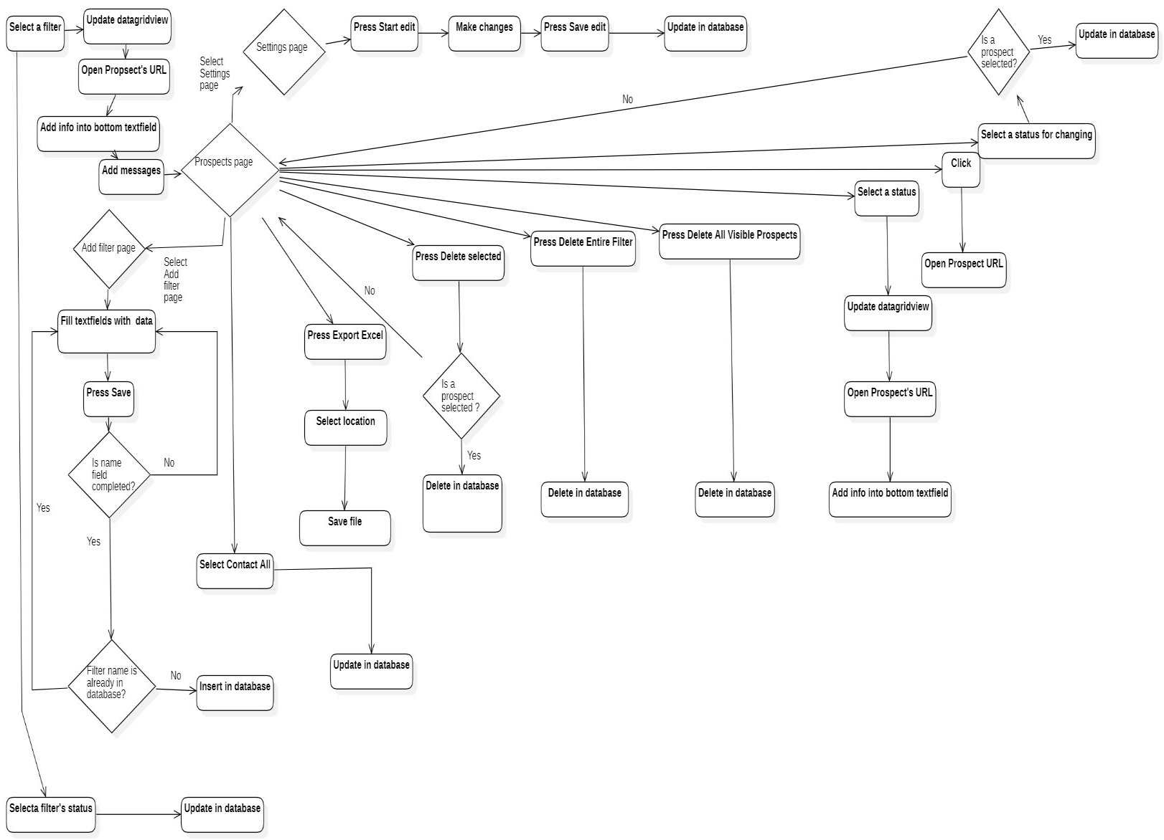

We will now get into more details for each tab of the application.

1. Add filter page

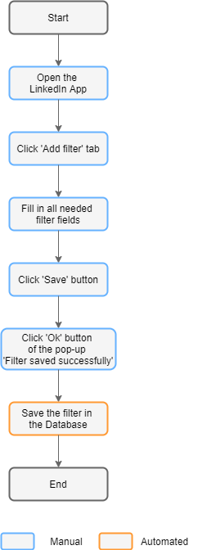

1. Prospects page

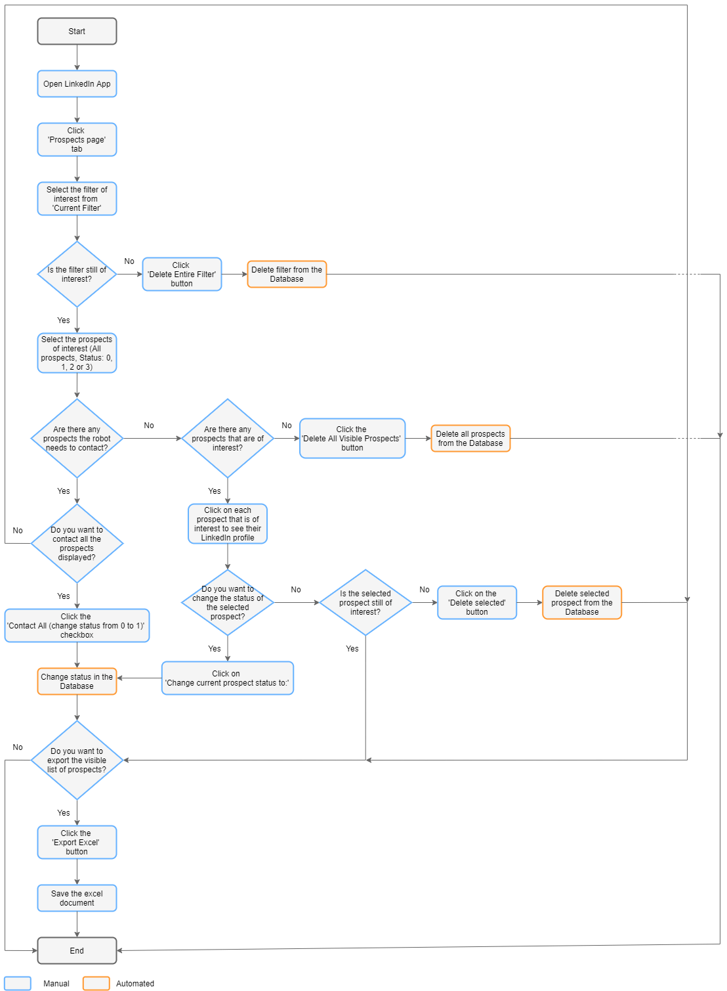

1. Setting page

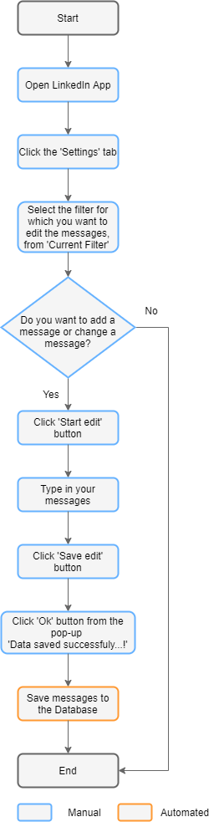

***Input***: data taken from a database with the following design, where: *Prospecti* table contains all prospects for processing, *FiltreKeywords* table contains all stored filters, *Setar*i table contains messages for each filter and *Filter* table is used to create a join between *FiltreKeywords* table and *Prospecti* table.

***Used tools***: Microsoft Visual Studio, SQL Server.

***Prerequisites***: LinkedIn Sales credentials, stable internet connection, Microsoft .NET 4.7.2 or greater, Visual C++ Runtime 2015 or greater (x86), Barracuda VPN connected.

***Output data***: .xls file (through the Export Excel button), SQL database queries, data from datagridview (in/out).

***Postconditions:*** Microsoft Excel installed for accessing generated file by Export Excel button.

***Errors***: not connected to VPN (access denied to database), prerequisites error for different version (installation error), a period of time exceeding a certain threshold (unstable connection), blank page on the embedded browser (invalid url link).